Drone Delivery System

**SUBMITTED IN PARTIAL FULFILLMENT FOR THE REQUIREMENT OF THE AWARD OF DEGREE OF**

### BACHELOR OF TECHNOLOGY IN

**INFORMATION TECHNOLOGY**



**Submitted by GROUP** -54

Priyanshu Gupta (1900290130129)

Mayank Saxena (1900290130092)

Shaumitra Sahu (1900290310146)

Utkarsh Gupta (1900290400137)

Mohit Singh (1900290130099)

**Supervised by**

Prof. Ruchin Gupta

# DEPARTMENT OF INFORMATION TECHNOLOGY KIET GROUP OF INSTITUTIONS, GHAZIABAD

**Session 2022-23**

## **DECLARATION**

We declare that the work contained in this report is original and has been done by us under the guidance of our supervisor. The work has not been submitted to any other institute for any degree or diploma. I/we have followed the guidelines provided by the institute to prepare the report. We have conformed to the norms and guidelines given in the ethical code of conduct of the institute. Wherever we have used materials (data, theoretical analysis, figures, and text) from other sources, we have given due credit to them by citing them in the text of the report and giving their details in the references.

Signature of the student Name: Priyanshu Gupta

Roll number: 1900290130129

Signature of the student Name: Mayank Saxena

Roll number: 1900290130092

Signature of the student Name: Shaumitra Sahu

Roll number: 1900290310146

Signature of the student Name: Utkarsh Gupta

Roll number: 1900290400137

Signature of the student Name: Mohit Singh

Roll number: 1900290130099

Place: KIET Group of Institutions, Ghaziabad Date:

# CERTIFICATE

This is to certify that Project Report entitled “Drone Delivery System” which is submittedby Group G-54 (Priyanshu Gupta, Mayank Saxena, Shaumitra Sahu, Utkarsh Gupta, Mohit Singh) in partial fulfillment of the requirement for the award of degree

B. Tech. in Department of Information Technology of Dr. A.P.J. Abdul Kalam Technical University, Lucknow is a record of the candidates own work carried out by them under my supervision. The matter embodied in this report is original and has not been submitted for the award of any otherdegree.

Signature of Supervisor:

Supervisor Name: Prof. Ruchin Gupta Date: 14th May 2023

# ACKNOWLEDGEMENT

It gives us a great sense of pleasure to present the report of the B. Tech Project undertaken during B. Tech. Final Year. We owe special debt of gratitude to Prof. Ruchin Gupta, Department of Information Technology, KIET, Ghaziabad, for his constant support and guidance throughout the course of our work. His sincerity, thoroughness and perseverance have been a constant source of inspiration for us. It is only his cognizant efforts that our endeavors have seen light of the day.

We also take the opportunity to acknowledge the contribution of Dr. Adesh Kumar Pandey, Head of the Department of Information Technology, KIET, Ghaziabad, for his full support and assistance during the development of the project. We also do not like to miss the opportunity to acknowledge the contribution of all the faculty membersof the department for their kind assistance and cooperation during the development of our project.

We also do not like to miss the opportunity to acknowledge the contribution of all faculty members, especially faculty/industry person/any person, of the department for their kind assistance and cooperation during the development of our project. Last but not the least, we acknowledge our friends for their contribution in the completion of the project.

Signature:

Name: Priyanshu Gupta Roll No: 1900290130129

Signature:

Name: Mayank Saxena Roll No: 1900290130092

Signature:

Name: Shuamitra Sahu Roll No: 1900290310146

Signature:

Name: Utkarsh Gupta Roll No: 1900290400137

Signature:

Name: Mohit Singh

Roll No: 1900290130099

# List of Figures

1. Frame 12
2. Brushless Motors 12
3. Propellers 12
4. ESC 13
5. Flight Controller KK 2.1.5 13
6. Battery 14
7. Main Drone System with Raspberry Pi as Controller 14
8. Motor Attaching to the Frame 15
9. ESCs being connected through Banana Connectors 15

**ABSTRACT**

The main aim of this project is to deliver packages using a drone to improve delivery service and security. In recent years, e-commerce businesses have seen an increase in the daily volume of packages to be delivered, as well as an increase in the number of particularly demanding customer expectations. In this respect, the delivery mechanism became prohibitively expensive, particularly for the final kilometer. To stay competitive and meet the increased demand, businesses began to look for innovative autonomous delivery options for the last mile, such as autonomous unmanned aerial vehicles/drones, which are a promising alternative for the logistics industry. Following the success of drones in surveillance and remote sensing, drone delivery systems have begun to emerge as a new solution to reduce delivery costs and delivery time. In the coming years, autonomous drone sharing systems will be an unavoidable logistical solution, especially with the new laws and recommendations introduced by the Flight World Organization on how to organize the operations of these special unmanned airline systems. This paper provides a comprehensive literature survey on a set of relevant research issues and highlights the representative solutions and concepts that have been proposed thus far in the design and modelling of the logistics of drone delivery systems, with the purpose of discussing the respective performance levels reached by the various suggested approaches. Furthermore, the paper also investigates the central problems to be addressed and briefly discusses and outlines a series of interesting new research avenues of relevance for drone-based package delivery systems.

Keywords: autonomous drones; vehicle routing problem; drone-based package delivery system; drone charging station repositioning; drone routing optimization; e-commerce delivery; drone assignment; drone delivery modeling.

# CONTENTS

Page No.

Declaration 1

Certificate 2

Acknowledgement 3

List of Figures 4

Abstract 5

CHAPTER 1: Introduction 7

CHAPTER 2: Literature Review 8

CHAPTER 3: 3.1 Code Editor & Hardware 10

* 1. Hardware 11
  2. Assembling 13

CHAPTER 4: 4.1 Methodology 15

CHAPTER 5: Result 16

CHAPTER 6: Future Scope 17

REFERENCES 18

APPENDIX A 20

APPENDIX B: A. Research Paper 21

B. Plagiarism Report 24

# CHAPTER 1

**Introduction**

A delivery drone is a type of unmanned aerial vehicle (UAV) used for distributing packages to consumers during the last mile delivery process several drone deliveries companies have started to gain traction in various transportation industries. What started as a passing fad has quickly turned into a legitimate enterprise.

Benefits of drone delivery are currently being tested but could include lower costs, higher operational efficiency, new revenue streams, instantaneous fulfillment, less congested roadways, fewer accidents and lower emissions. Since delivery drones are not yet an established solution, a few of the limitations being researched are package weight limitations, flight time and range constraints due to battery life, collision avoidance systems and how to handle unpredictable events such as weather or being hacked.

As e-commerce continues to grow and traditional forms of delivery are no longer the most efficient option, delivery companies are experimenting with the implementation of drones. Businesses such as USPS, Amazon and Google have undertaken drone experiments as a feasible alternative for growth. The current most popular use cases for delivery drones are time sensitive materials such as medicine and food or small items for same-day delivery. Below, we’ll answer the common question, “What is drone delivery service?” We’ll also explain how drone delivery systems work and highlight some of the companies that are already taking advantage of this new technology.

# CHAPTER 2

**Literature Review**

The drone lifts off from point A and flies to point B with a package that needs to be delivered [1]. "Flight Station" refers to location A, and "Drop Station" refers to location B. An H-helipad sign has been constructed on each side so that a drone can read it and determine whether it is a drop station or a flight station. The drone is moved to its target using the Routing Algorithm [2]. This algorithm determines the quickest path for the package's prompt delivery.

The drone is made up of parts such as flight controller, brushless motors, a processing unit, a GPS, cameras, and object detection sensors, among others. An e-commerce delivery drone does, however, come with an additional display component to show the generated QR-code for scanning and making the payment via it. It is possible to utilise the processor like an Arduino, although a Raspberry Pi with more functionalities is recommended [3]. The drone will actually need internet services like 5G or 4G-VoLTE in order to operate and communicate with the main centre through the internet.

Complete supervision is necessary when the drone is in flight mode. If the drone loses control, there ought to be a manual control option. However, the delivery problem is considered a stochastic problem and uses a large fleet of fully autonomous drones in the delivery system, thus making the modelling very challenging. Since the inception of robotics, creating obstacle avoidance systems has been a difficult task [4,5]. This results from the requirement to build autonomous robots capable of dodging unforeseen hazards in their environment using just the data gathered by onboard sensors. Khatib's early solution to the issue involved employing artificial potential fields to repel wheeled mobile robots from barriers and draw them towards a desired location. The main drawback of Khatib's approach is the potential for local minima to exist in the potential field, trapping the vehicle.

The approach utilized by Key points is predicated on the use of SIFT features. The end product was judged to have good performance both in terms of computation time and overall detection performance technique.

Due to the method's intrinsic adaptability, it could be used to characteristics other than SIFT, like the FAST-BRIEF pair and BRISK, which performed better in a range of contexts. The benefits of incorporating these categories of features into the suggested technique will be the subject of future investigations.

The DACS (Drone Anti-Collision System) is also called SAA (Sense and Avoid) or DAA (Detect and Avoid) often [6]. The DACS relies on the group of sensors for sensing and responding to the obstacle. On the other hand, sensors can do the job well because they do not possess hectic of

the data processing and thus, delay will be minimal [7]. Ultrasonic sensors will send ultrasonic soundwaves to sense the real-time environment while PIR Motion Detection sensor will detect any movement of foreign object nearby. In advance drone systems, which are BLVOS (Below Visual Line of Sight), LiDAR and EO/IR (Electro-optical/Infrared) sensors are used that provide identity, location and other important insights [8].

The drones in a drone delivery system won't be using the current map capabilities, which only provide road navigation; instead, the drones will need to take a different route, flying over buildings to get to their destination as rapidly as feasible [9]. Like with aircraft, the itineraries for the drones will vary. Flights follow their own routes as they travel from place to place. The same flight path will be assigned to the drones, but on a smaller scale and exclusively within the city. They will go the shortest route while flying over buildings to reach their target [10].

Later, Jeon et al. addressed the same routing problem by using MILP models and some heuristics based on the approach proposed by Murray and Chu. This proposed method involves reducing the number of empty flights in order to increase drone utilization; it is being tested on Jeju Island using localization and tracking data. Dorling et al. [11] addressed two multi-trip vehicle routing problems that incorporate battery and payload weights into the energy consumption calculations; the first problem deals with the cost issue of a delivery time constraint, and the second problem seeks to optimize the delivery time subject to a cost limit. Furthermore, the proposed algorithms seek to optimize the drone fleet size as well as the trips for the delivery of the package. The authors assumed that the operator has enough fully charged batteries to satisfy the drone energy requirements before the deliveries can start and that the operator deploys only one depot (charging station) in the area.

In contrast, it would be very challenging and costly for a delivery company to deploy multiple depots and battery swapping stations, as well as manage battery swapping between trips to meet the daily demand [12,13].

Wang addressed the vehicle routing problem with drones, where the fleet consists of multiple trucks equipped with multi-drones to minimize the completion time. Both vehicles can deliver the packages, and the trucks must wait for the drone after it has been deployed for a delivery.

They proposed a routing strategy called “The Drone Vehicle Traffic Problem”, where the objective is to serve all customers within the shortest time duration. Moreover, a scheduling model was formulated to determine the time at which a battery begins/stops charging or begins/stops discharging. Sawadsitang et al. [13] developed a suppliers’ cooperation policy to share the total cost of a drone delivery service.

This means that suppliers can serve their customers collaboratively and share their drones in order to serve as many customers as possible; when a drone drops a package at the desired destination, it can return to any supplier depot that is part of the cooperation system.

The proposed optimization model considers the parcel assignment problem as mixed integer programming. In addition, they did not consider the battery range issue in their modeling. To the best of our knowledge, no short-term assignment strategies have been proposed to improve the efficiency of an autonomous drone-based delivery service in real time. For instance, in fast-food meal delivery services, customers need to be served quickly, especially during peak hours, which represents a challenge for scheduling the drone fleet.

According to the review of the most relevant and most recent papers on drone-based parcel delivery systems, many drone delivery problems have been addressed, indicating the importance of drones in resolving many logistical problems, particularly in the last mile, and transforming the future of package delivery. However, in order to launch a drone delivery system in an urban area, the level of urban aerospace must be capable of dealing with high delivery drone traffic densities. Doole et al. [14, 15] proposed a method for estimating the traffic demand for a typical dense European city’s drone-based delivery system.

Furthermore, significant assumptions were included to simplify the modeling of this autonomous logistic mode in these research works. It is important to note that drone delivery performance is highly constrained by the battery range, payload, customer location, and weather conditions in which it is operating. These significantly influence the time delivery; thus, they must be included when modeling drone delivery systems.

# CHAPTER 3

* 1. **Code Editor & Hardware**

### Jupyter

The Jupyter Notebook is an open-source web application that allows you to create and share documents that contain live code, equations, visualizations and narrative text. Uses include: data cleaning and transformation, numerical simulation, statistical modelling, data visualization, machine learning, and much more. Notebook documents contains the inputs and outputs of a interactive session as well as additional text that accompanies the code but is not meant for execution. In this way, notebook files can serve as a complete computational record of a session, interleaving executable code with explanatory text, mathematics, and rich representations of resulting objects. These documents are internally JSON files and are saved with the .ipynb extension. Since JSON is a plain text format, they can be version- controlled and shared with colleagues.

### Raspberry Pi

Raspberry Pi is a series of small single-board computers (SBCs) developed in the United Kingdom by the Raspberry Pi Foundation in association with Broadcom. The Raspberry Pi project originally leaned towards the promotion of teaching basic computer science in schools. The original model became more popular than anticipated, selling outside its target market for uses such as robotics. It is widely used in many areas, such as for weather monitoring, because of its low cost, modularity, and open design. It is typically used by computer and electronic hobbyists, due to its adoption of the HDMI and USB standards.

### Frame

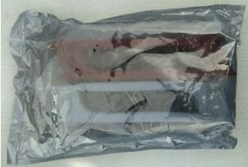

**Figure 1. Frame**

A frame/chassis of drone is the main structure that holds all the parts of drone together.

### Motors

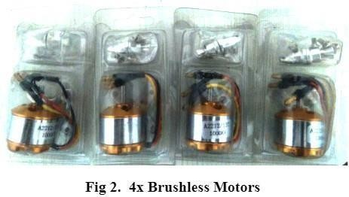

Brushless motor with specifications of 1000KV with 13000-15000 rpm.

### Propellers

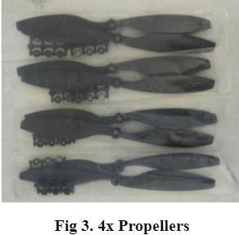

### ESC

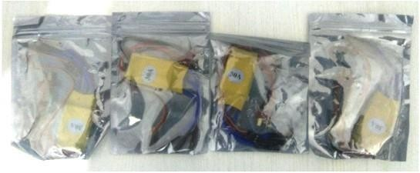 **Figure 4. ESCs*4**

Electronic speed controllers (ESCs) are devices that allow drone flight controllers to control and adjust the speed of the aircraft’s electric motors.

### Flight Controller

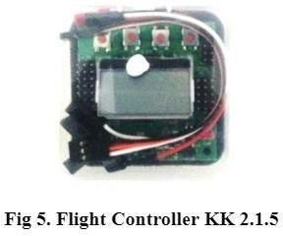

KK2.1.5 is a flight controller; the flight controller is also called the brain of the drone because with this all the operation of the drone is controlled. KK2.1.5 has ATMEL mega 664PA IC inbuilt inside it. It is an 8-bit AVR RISC based microcontroller with 64k of memory. It has inbuilt accelerometer and gyroscope, 6050 MPU and auto level function. It has eight motor outputs at the right side of the board; we connect ESC here. It has 5 control inputs; these inputs are connected through a receiver. It also has one LCD display in the middle, it will work as a user interface for the drone. Its operating voltage is 1.8V to 5.5V and its input voltage is 4.8-6.0 V.

### Batteries Figure 6. Battery

### Assembled

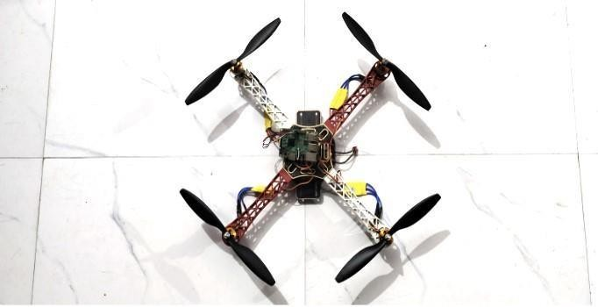

Fig.7 Main Drone System with Raspberry Pi as Controller

* + - * Hardware and Building Phase: Assemble the F450 quadrotor frame and the printed battery casing in the middle (make sure to add the M2.5*5mm spacers).

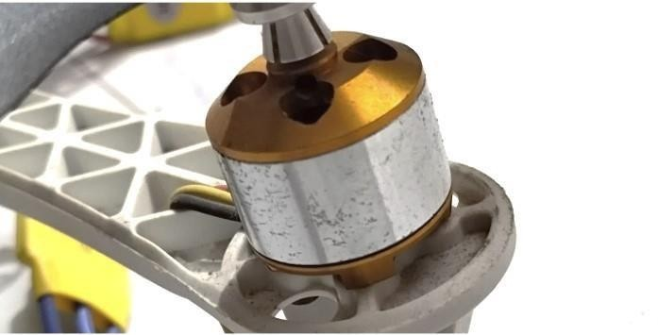

**Figure 8. Motor attaching to the frame**

* + - * Attach the motors to the frame.

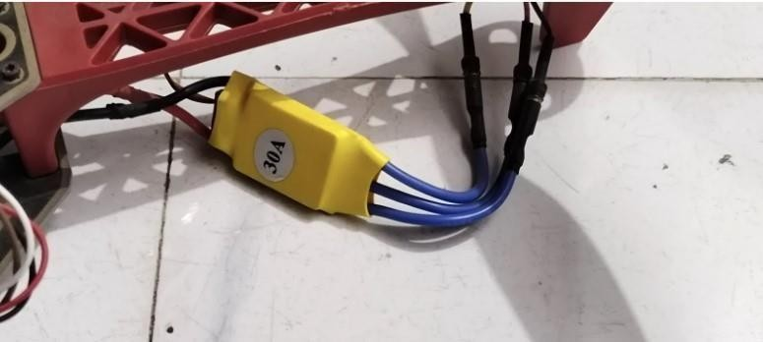

**Figure 9. ESC being connected through Banana Connectors**

* + - * Solder the banana connectors to the ESCs and motors wires. Solder the ESCs and the power module to the PDB. Note: Make sure not to use the 5V output of the PDB.

# CHAPTER 4

**4.1 Methodology**

STEP 1: Making of the Frame

The primary task is to form a frame. For this purpose, you’ll use different materials, like metal, plastic, or wood. These materials will differ supported by how sturdy you plan the drone to be.

STEP 2: Propellers, Electronic Speed Controllers and Motors

* The ESCs (Electronic Speed Controllers), the motors, and therefore the propellers are among the foremost important elements of a functional drone.
* Put the motor within the appropriate place and fix it to the frame using the screws and a screwdriver.
* After mounting the motors, you furthermore may need to mount the speed controllers. How will you be doing this? It is recommended to attach the speed controllers on the bottom side of the wings of the frame.
* Now attach the propellors to the motor, and keep the direction of the propellor for the right movement
* Clockwise or Counter-Clockwise.
* The wings of the drone are now ready. Now solder the ESC inputs to the Power Distribution Board.

STEP 3: Flight Controller

* Every flying drone must have an impact system. This electronic system allows a drone to be stable within the air while flying and processes all the shifts and changes in direction and therefore the wind
* Now, fix the flight controller to the frame at a center position for good stability.

STEP 4: External GPS

Now, Attach the external GPS to the frame and make sure that external GPS is not very near to the flight controller because it causes interference because of the magnetometer in the flight controller.

STEP 5: Connection to the Flight Controller

Now connect the ESC to the flight controller output port, GPS to the GPS port and Power module to the PM port of the flight controller.

STEP 6: Radio Receiver

Now, connect channel no. 1-5 to the input of the flight controller. The Channel 1-4 is for Pitch, Roll, Throttle & Yaw. Channel 5 is for flight modes like Stabilize, Position hold etc.

The construction of Drone is now complete. All we need is to upload the latest firmware available for the Quadcopter drone by using the Mission Planner software.

And, after uploading the firmware, we need to calibrate the GPS and each ESC.

# CHAPTER 5

* 1. **Result**

This paper focused on drone delivery system, a common yet not commercially implemented methodology to locate and transport the required packages, highlighting the arduousness, and identify the possible solutions to them up to a great extent. The model improves productivity and accelerates project execution time. The study's significance lies in its contribution to improving supply chain efficiency and reducing the need for manual searches and physical transportation. The drone's mission is to fly over mountains or wilderness and spot humans or irregular objects and then process that to see if that person needs help. Depending on the nature of their operations, these unmanned flying devices can transport various sensors, including acoustic, optical, chemical, and biological ones. Researchers have concentrated on optimizing drone designs to increase their effectiveness and performance, which has led to the creation of a variety of aerial vehicles with a range of capabilities.

**CHAPTER 6**

**Future Scope**

Future work will focus on creating sophisticated control systems with more capabilities. These involve the use of advanced artificial intelligence methods. Solar energy will eventually take the place of batteries as a source of power. As a result, an industry will develop that will support the ecosystem and be able to benefit everyone. These drones can help in receiving & retrieving information from customers. Not only that in the future, but these drones can also help in receiving the weather information too. In the future, we can also develop this project more and more securely like authorizing the person by Bio-Metric or by Face Recognition etc.

### REFERENCES

* + 1. Torabbeigi, M., Lim, G.J., Ahmadian. (2021). An Optimization Approach to Minimize the Expected Loss of Demand Considering Drone Failures in Drone Delivery Scheduling. J Intell RobotSyst 102,22 <https://doi.org/10.1007/s10846-021-01370-w>
    2. Waykule, Jyoti. (2020). Smart Drone Delivery System.
    3. Chettri, Prasant & Giri, Rajni & Lepcha, Zerong & Lal, Arvind. (2022). PI Drone using Python. International Journal of Engineering and Technical Research. Volume 10. 221- 226.
    4. Aditya Bhardwaj , Achira Basu , Dr. A.Senthil Selvi, 2019, Package Delivery System Using GPS Drones, INTERNATIONAL JOURNAL OF ENGINEERING RESEARCH & TECHNOLOGY (IJERT) Volume 08, Issue 10 (October 2019)
    5. Al-Kaff, Abdulla & Garcia, Fernando & Martín Gómez, David & de la Escalera, Arturo & Armingol, J.M.. (2017). Obstacle Detection and Avoidance System Based on Monocular Camera and Size Expansion Algorithm for UAVs. Sensors. 17. 1061. 10.3390/s17051061.
    6. J. N. Yasin, S. A. S. Mohamed, M. -H. Haghbayan, J. Heikkonen, H. Tenhunen and J. Plosila, "Unmanned Aerial Vehicles (UAVs): Collision Avoidance Systems and Approaches," in IEEE Access, vol. 8, pp. 105139-105155, 2020, doi: 10.1109/ACCESS.2020.3000064.
    7. Cruz, Gonçalo & Encarnação, Pedro. (2012). Obstacle Avoidance for Unmanned Aerial Vehicles. Journal of Intelligent and Robotic Systems. 65. 203-217. 10.1007/s10846-011- 9587-z.
    8. Collision & Obstacle Avoidance: <https://www.unmannedsystemstechnology.com/expo/collision-obstacle-avoidance/>
    9. Shreyas Shreedhar Devekar, Tushar Manohar Pawar, Yogesh Mahadev Lande, and Sunil Deokule. "Autonomous Drone Delivery System for Lightweight Packages." International Journal Of Advance Research And Innovative Ideas In Education 5, no. 3 (2019) : 1128- 1133.
    10. Saunders, Jack & Saeedi, Sajad & Li, Wenbin. (2021). Autonomous Aerial Delivery Vehicles, a Survey of Techniques on how Aerial Package Delivery is Achieved.
    11. Qays, Hasan & Salman, Aymen & Baki, Bassim-Abdul. (2020). Autonomous Quadcopter Delivery System. Xi'an Jianzhu Keji Daxue Xuebao/Journal of Xi'an University of Architecture & Technology. 12. 1504-1516.
    12. Jeevan G Murthy, Harshith P S, Joel J Antony, K Rakesh, Sharath Kumar A J. Autonomous Drone Delivery System: A Survey. International Research Journal of Engineering and Technology (IRJET). Volume: 07 Issue: 03 | Mar 2020.
    13. Sakhardande, Vedant & Rodrigues, Cajetan & Atre, Atharva. (2020). Drone Delivery- Application and Path Optimization. IX. 947.
    14. Benarbia, Taha, and Kyandoghere Kyamakya. 2022. "A Literature Review of Drone- Based Package Delivery Logistics Systems and Their Implementation Feasibility" Sustainability 14, no. 1: 360. <https://doi.org/10.3390/su14010360>
    15. Shahmoradi, Javad, Elaheh Talebi, Pedram Roghanchi, and Mostafa Hassanalian. 2020. "A Comprehensive Review of Applications of Drone Technology in the Mining Industry" Drones 4, no. 3: 34. https://doi.org/10.3390/drones4030034
    16. D. K. Behera and A. Bazil Raj, "Drone Detection and Classification using Deep Learning," 2020 4th International Conference on Intelligent Computing and Control Systems (ICICCS), Madurai, India, 2020, pp. 1012-1016, doi: 10.1109/ICICCS48265.2020.9121150.

**ANNEXURE 1**

**Title of Paper:** Developing Autonomous Drone Delivery System in field of E-Commerce and Business

**Name of Scopus Conference:** ICICAT 2023

**Date of Submission**: 17/05/2023 **Date of acceptance:** Pending **Date of Publication:** Pending.

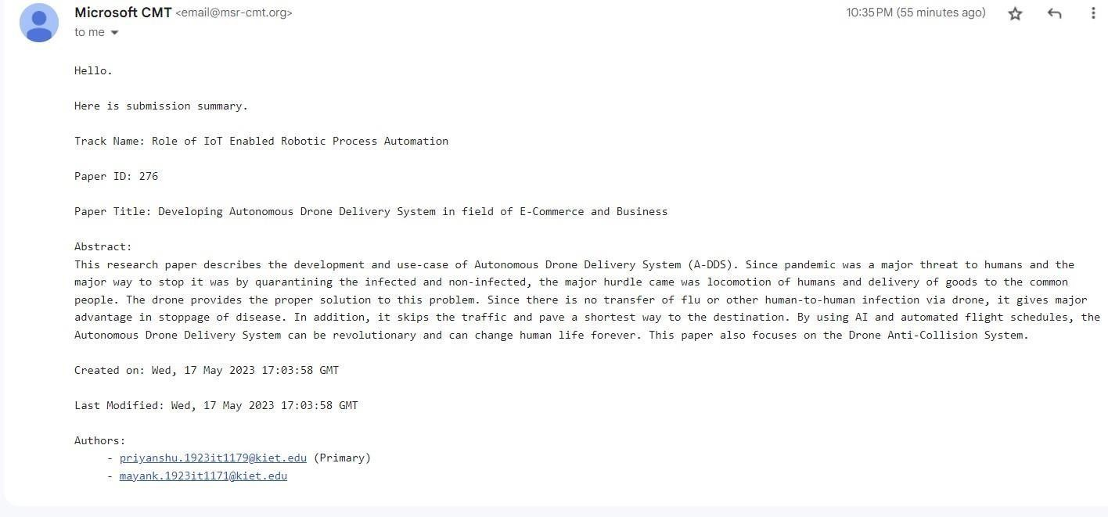

**Annexure 2**

1. **Research Paper**

**Developing Autonomous Drone Delivery System in field of E-Commerce and Business**

|  |  |  |  |
| --- | --- | --- | --- |
| Priyanshu Gupta | Mayank Saxena | Ruchin Gupta | Shaumitra Sahu |
| Department of IT | Department of IT | Department of IT | Department of IT |
| *KIET Group of Institutions,* | *KIET Group of Institutions,* | *KIET Group of Institutions,* | *KIET Group of Institutions,* |
| *Delhi-NCR,* | *Delhi-NCR,* | *Delhi-NCR,* | *Delhi-NCR,* |
| *Ghaziabad, India* | *Ghaziabad, India* | *Ghaziabad, India* | *Ghaziabad, India* |

***Abstract—* This research paper describes the development and use-case of Autonomous Drone Delivery System (A- DDS). Since pandemic was a major threat to humans and the major way to stop it was by quarantining the infected and non-infected, the major hurdle came was locomotion of humans and delivery of goods to the common people. The drone provides the proper solution to this problem. Since there is no transfer of flu or other human-to-human infection via drone, it gives major advantage in stoppage of disease. Another thing is that it can move to places in no time. By using AI and automated flight schedules, the Autonomous Drone Delivery System can be revolutionary and can change human life forever. This paper also focuses on the Drone Anti-Collision System**.

***Keywords*—** Drone, Automated System, Delivery Optimization

1. INTRODUCTION

COVID-19 pandemic had a very destructive impact on the industries, with many companies struggling to manage capital projects with limited resources. Shutdowns, layoffs, and funding cuts have been widespread, and the industry is still grappling with supply chain disruptions and material shortages. To adapt to this new reality, the E-commerce industry has embraced innovative solutions to improve efficiency and productivity in a post-pandemic world.

Major focus is the use of automation technology, such as RFID (Radio Frequency Identification), GPS, AI, and drones. Drones have insane potential to do human tasks like delivering goods and also reduce the need for human intervention and accessing remote or hazardous locations. The pandemic has accelerated the adoption of drone technology, and regulatory relaxations have further expanded their use.

An unmanned aerial vehicle (UAV) is one that is not piloted by a human being but instead operated by a controller or a companion computer. The majority of drones in use today are controlled manually, although internet-connected drones are capable of long-range autonomous missions. Therefore, it can more accurately transport lightweight packages over great distances in remote locales during an emergency were

delivery would otherwise take longer.

how drones equipped with video and GPS capability, paired with smart tag readers, QR-code generated payment system, Anti-collision system can be better than normal logistic transportation.

1. LITERTURE REVIEW
2. *Model Design of A-DDS*

First, the drone lifts off from point A and flies to point B with a package that needs to be delivered [1]. "Flight Station" refers to location A, and "Drop Station" refers to location B. An H- helipad sign has been constructed on each side so that a drone can read it and determine whether it is a drop station or a flight station. The drone is moved to its target using the Routing Algorithm [2]. This algorithm determines the quickest path for the package's prompt delivery.

The drone is made up of parts such as flight controller, brushless motors, a processing unit, a GPS, cameras, and object detection sensors, among others. An e-commerce delivery drone does, however, come with an additional display component to show the generated QR-code for scanning and making the payment via it. It is possible to utilise the processor like an Arduino, although a Raspberry Pi with more functionalities is recommended. The drone will actually need internet services like 5G or 4G-VoLTE in order to operate and communicate with the main centre through the internet. Complete supervision is necessary when the drone is in flight mode. If the drone loses control, there ought to be a manual control option.

1. *Image Recognition via AI*

The drone will detect the helipad symbol using the Raspberry PI Cam and OpenCV technology [3]. The camera can be replaced by the normal web cam also but there may be configuration issues.

The main steps to connect the cam module to Raspberry Pi is as follows:

* + We have to plug the camera module to the camera port of the Raspberry Pi.
  + Then, we have to enable camera port in Raspberry Pi configuration tool.
  + Finally, we will check whether the camera is

This paper presents the roadmap for Autonomous drones, AI and GPS in the post-pandemic era. The model demonstrates

working or not.

* + For checking the working of cam, raspistill -o test.jpg command is used in Raspberry Pi terminal.
  + This will click an image from cam.

In order to implement OpenCV for Letter H-recognition, we can use Tesseract module and OpenCV together. In general, this can be done as follows:

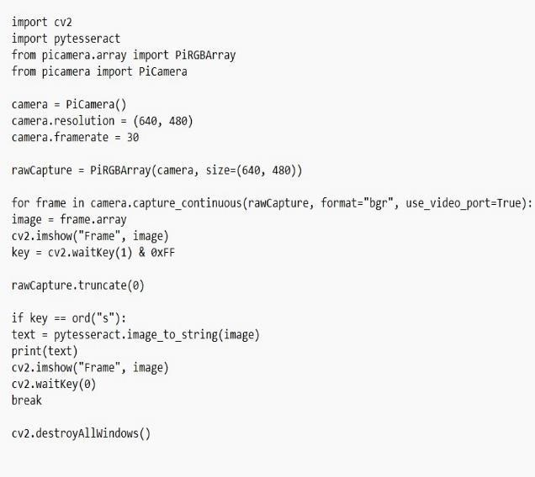

After the recognition of Helipad station, the drone can land right away and further process can be done.

1. *Drone Anti-Collision System (DACS)*

Since the inception of robotics, creating obstacle avoidance systems has been a difficult task [4,5]. This results from the requirement to build autonomous robots capable of dodging unforeseen hazards in their environment using just the data gathered by onboard sensors. Khatib's early solution to the issue involved employing artificial potential fields to repel wheeled mobile robots from barriers and draw them towards a desired location. The main drawback of Khatib's approach is the potential for local minima to exist in the potential field, trapping the vehicle.

The configuration of 62 degrees ensured the capability of detecting the edge of an object the size of the actual drone positioned in the centre of the image at farther distances. For greater barriers or tighter distances, the drone demonstrated the ability to halt and perform a hover movement, avoiding collision. The 15 cm that enables obstacle avoidance. Larger obstructions that were farther away were avoided because of the employment of a good camera that could spot obstacles far away.

The approach utilized by Key points is predicated on the use of SIFT features. The end product was judged to have good performance both in terms of computation time and overall detection performance technique. Due to the method's intrinsic adaptability, it could be used to characteristics other than SIFT, like the FAST-BRIEF pair and BRISK, which performed better in a range of contexts. The benefits of incorporating these categories of features into the suggested technique will be the subject of future investigations.

The DACS (Drone Anti-Collision System) is also called SAA (Sense and Avoid) or DAA (Detect and Avoid) often [6]. The DACS relies on the group of sensors for sensing and responding to the obstacle. The simple logic that can be used is to move in the opposite direction of the obstacle. The

impediment will actually fly into the air or birds may attack drones because they see them as a threat.

The main sensors that can be used are Ultrasonic Sensors and PIR Motion Detection Sensors. These sensors will have to be installed on the four side of drone (if the drone is a quadcopter), else depends on the other drone design.

Cameras can also be installed but that will be too slow to respond. Cameras need to process the recording first and then the real time recording needs to be sent to main centre for applying AI or ML or DL algorithm because a single board computer can’t do that much processing due to limited hardware units. After processing the real time recording, the data needs to be sent back to the drone to respond to the obstacle. Hence, cameras are not installed as an obstacle detector.

On the other hand, sensors can do the job well because they do not possess hectic of the data processing and thus, delay will be minimal [7]. Ultrasonic sensors will send ultrasonic soundwaves to sense the real-time environment while PIR Motion Detection sensor will detect any movement of foreign object nearby. In advance drone systems, which are BLVOS (Below Visual Line of Sight), LiDAR and EO/IR (Electro- optical/Infrared) sensors are used that provide identity, location and other important insights [8].

1. *Using QR-code Generated Payment*

The link for the payment is generated on the website whenever a purchase is made. In the conventional way, the customer must go through the checkout process, proceed with their payment using a credit card, debit card, UPI, or other payment system, and then proceed to the payment gateway. In this scenario, the customer will receive a drone landing, and the QR-code is produced from the payment link displayed on the drone's display. When the customer scans the QR code, the website will redirect to the payment gateway, where the transaction will be completed. The drone will get a signal to release the package and return to the primary headquarters after the payment has been completed. Numerous third-party services are provided by organizations like Razorpay, Paytm, etc.

1. BASIC FUNCTIONING

Functioning Framework of Drones flowchart is shown in Figure 1. The command for the delivery of the package is received by the base or warehouse. The signal is then sent from the base to the designated drone. In order to avoid obstructions and disruptions, it takes off while climbing to a greater height [4]. The drone is directed towards the intended location along a path that has been set to the delivery site. The drone is given the customer's precise location as it reaches a greater height, and it is continually updated so that it can follow the location as it travels to its destination [9].

The distribution point's GPS position will be read by the drone in line with the architecture design. After reading

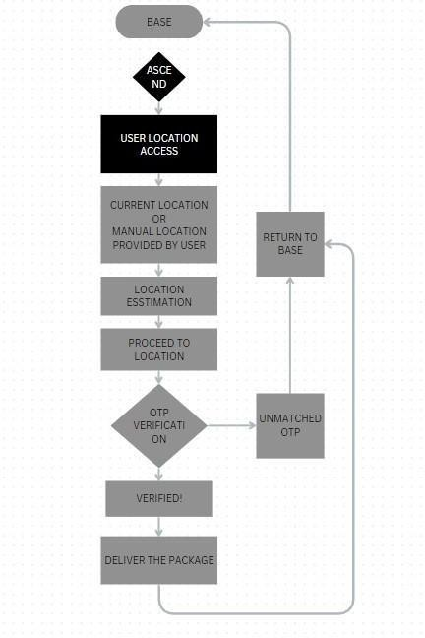 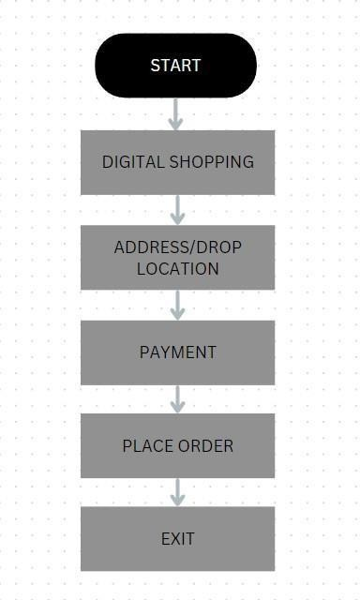

Figure 1: Flowchart of Operation of Drones

the precise position, it will keep track of its present location continually before leaving the base. It will fly to the delivery area and check that the package belongs to the correct customer by requesting the OTP given to the confirmed device. It will deliver the package and then bring it back to the base after receiving confirmation. If the OTP is invalid, the drone won't lower itself and return to the base, indicating that it didn't check. Up until the package is handed over to the intended receiver, the cycle will go on [4].

The method for locating the consumer is shown in Figure 2. The customer will be prompted for their address during the process of placing an order. They will have the choice to manually enter their location or to provide their real location. In both situations, they must set their position on the given map. The drone will have a distinctive design, remove obstructions, use image processing to detect obstructions, and be secure during storms and bad weather. Once there, it can be lowered using appropriate functionalities after it has reached the individuals.

The drones in a drone delivery system won't be using the current map capabilities, which only provide road navigation; instead, the drones will need to take a different route, flying over buildings to get to their destination as rapidly as feasible [10]. Like with aircraft, the itineraries for the drones will vary. Flights follow their own routes as they travel from place to place. The same flight path will be assigned to the drones, but on a smaller scale and exclusively within the city. They will go the shortest route while flying over buildings to reach their target [9].

Figure 2: Order Placement

1. CONCLUSIONS AND FUTURE SCOPE

This paper focused on drone delivery system, a common yet not commercially implemented methodology to locate and transport the required packages, highlighting the arduousness, and identify the possible solutions to them up to a great extent. The model improves productivity and accelerates project execution time. The study's significance lies in its contribution to improving supply chain efficiency and reducing the need for manual searches and physical transportation. Future work will focus on creating sophisticated control systems with more capabilities. These involve the use of advanced artificial intelligence methods. Solar energy will eventually take the place of batteries as a source of power. As a result, an industry will develop that will support the ecosystem and be able to benefit everyone.

1. REFERENCES
2. Torabbeigi, M., Lim, G.J., Ahmadian. (2021). An Optimization Approach to Minimize the Expected Loss of Demand Considering Drone Failures in Drone Delivery Scheduling. J Intell RobotSyst 102,22 https://doi.org/10.1007/s10846-021-01370- w
3. Waykule, Jyoti. (2020). Smart Drone Delivery System.
4. Chettri, Prasant & Giri, Rajni & Lepcha, Zerong & Lal, Arvind. (2022). PI Drone using Python. International Journal of Engineering and Technical Research. Volume 10. 221-226.
5. Aditya Bhardwaj , Achira Basu , Dr. A.Senthil Selvi, 2019, Package Delivery System Using GPS Drones, INTERNATIONAL JOURNAL OF

ENGINEERING RESEARCH & TECHNOLOGY

(IJERT) Volume 08, Issue 10 (October 2019)

1. Al-Kaff, Abdulla & Garcia, Fernando & Martín Gómez, David & de la Escalera, Arturo & Armingol, J.M.. (2017). Obstacle Detection and Avoidance System Based on Monocular Camera and Size Expansion Algorithm for UAVs. Sensors. 17. 1061. 10.3390/s17051061.
2. J. N. Yasin, S. A. S. Mohamed, M. -H. Haghbayan,

J. Heikkonen, H. Tenhunen and J. Plosila, "Unmanned Aerial Vehicles (UAVs): Collision Avoidance Systems and Approaches," in IEEE Access, vol. 8, pp. 105139-105155, 2020, doi: 10.1109/ACCESS.2020.3000064.

1. Cruz, Gonçalo & Encarnação, Pedro. (2012). Obstacle Avoidance for Unmanned Aerial Vehicles.

Journal of Intelligent and Robotic Systems. 65. 203- 217. 10.1007/s10846-011-9587-z.

1. Collision & Obstacle Avoidance: [https://www.unmannedsystemstechnology.com/exp](https://www.unmannedsystemstechnology.com/expo/collision-obstacle-avoidance/) [o/collision-obstacle-avoidance/](https://www.unmannedsystemstechnology.com/expo/collision-obstacle-avoidance/)
2. Shreyas Shreedhar Devekar, Tushar Manohar Pawar, Yogesh Mahadev Lande, and Sunil Deokule. "Autonomous Drone Delivery System for Lightweight Packages." International Journal Of Advance Research And Innovative Ideas In Education 5, no. 3 (2019) : 1128-1133.
3. Saunders, Jack & Saeedi, Sajad & Li, Wenbin. (2021). Autonomous Aerial Delivery Vehicles, a Survey of Techniques on how Aerial Package Delivery is Achieved.

### B. Plagiarism Report

